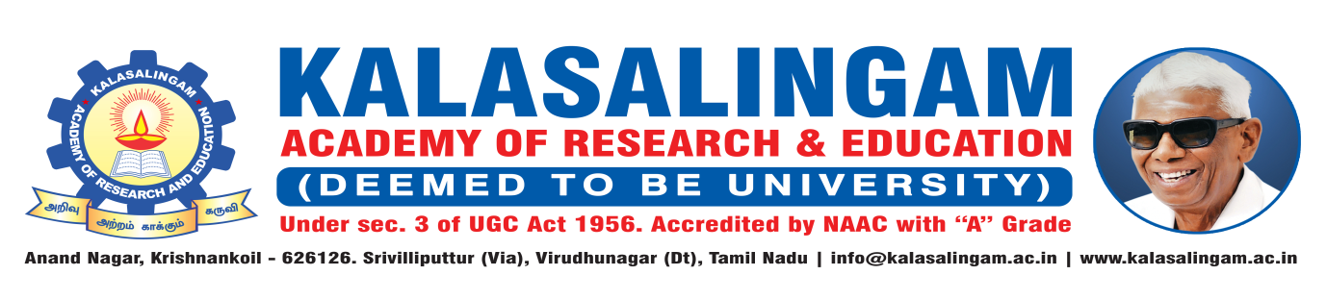
DEPARTMENT OF PHYSICAL EDUCATION
Date: 07.08.2023
SPORTS ACHIEVEMENTS
AUGUST 2023

- Our University Yoga Men &Women team participated in the Virudhunagar District level Yogasana Championship Competitions 2023 and won Medals organized by Lion M.Ponnaiya Yogasana Institution, Srivilliputtur at Srivi Lions Matric High.Sce.School, Srivilliputtur on 06th August,2023.

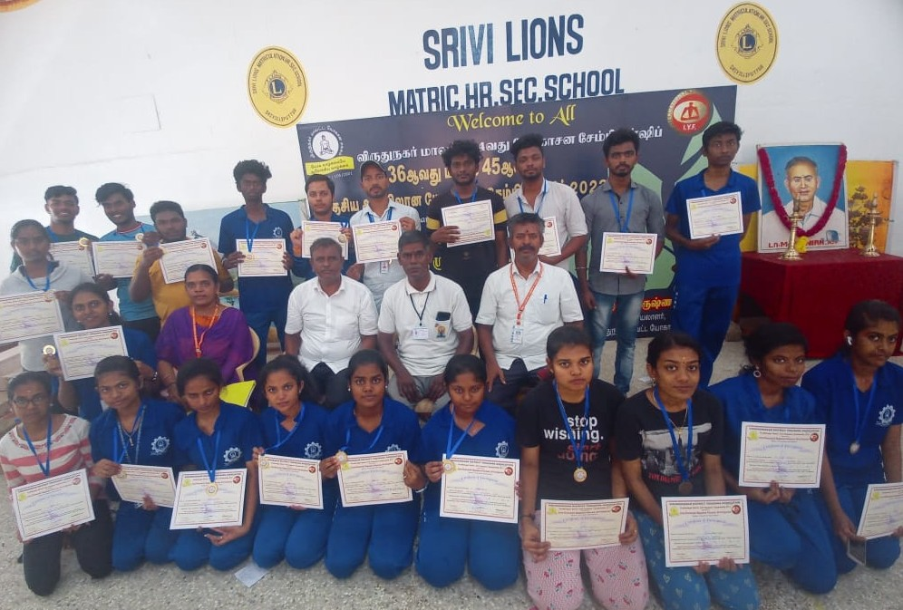

S.NO | NAME | REG.NO | YEAR/ DEPT | POSITION
1 | SANTHIYA DEVI | 9922150193 | II MBA | V
2 | JAYA VIGNESSH | 9922008229 | II IT | V
3 | CHARUMATHI K | 9922008284 | II IT | VI

